**WEEK 6 HandsOn :**

**HandsOn Task 3 :**

Create a react app for Student Management Portal named scorecalculatorapp and create a function component named “CalculateScore” which will accept Name, School, Total and goal in order to calculate the average score of a student and display the same.

**CODES AND OUTPUTS :**

**1 . Crete react app using command :**

npx create-react-app scorecalculatorapp

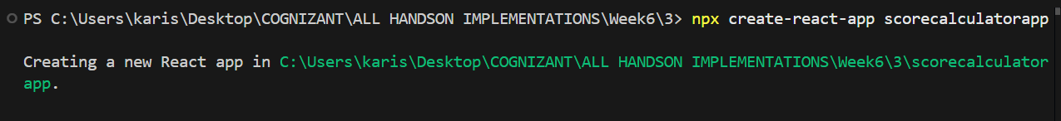

cd scorecalculatorapp

npm start

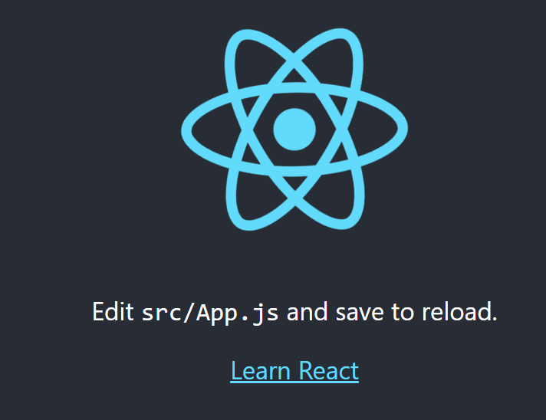

**Folder Structure :**

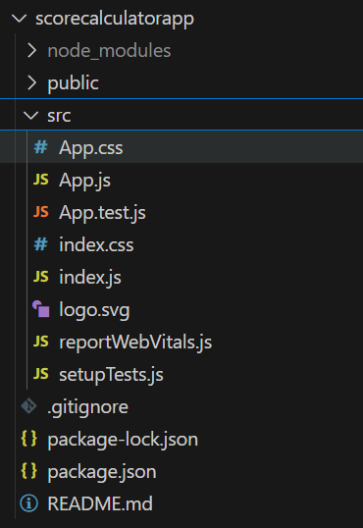

**2 . Create a new folder under Src folder with the name “Components”. Add a new file named “CalculateScore.js”**

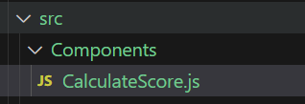

**CalculateScore.js :**

import React from 'react';

import '../Stylesheets/mystyle.css';

const CalculateScore = ({ name, school, total, goal }) => {

// Calculate average score

const calculateAverage = () => {

if (total && goal) {

return ((total / goal) * 100).toFixed(2);

}

return 0;

};

const averageScore = calculateAverage();

return (

<div className="score-container">

<h2>Student Score Calculator</h2>

<div className="student-info">

<p><strong>Name:</strong> {name}</p>

<p><strong>School:</strong> {school}</p>

<p><strong>Total Marks:</strong> {total}</p>

<p><strong>Goal Marks:</strong> {goal}</p>

</div>

<div className="score-result">

<h3>Average Score: {averageScore}%</h3>

</div>

</div>

);

};

export default CalculateScore;

**3 .** **Create a Folder named Stylesheets and add a file named “mystyle.css” in order to add some styles to the components:**

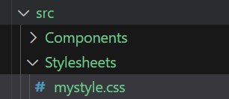

**mystyle.css :**

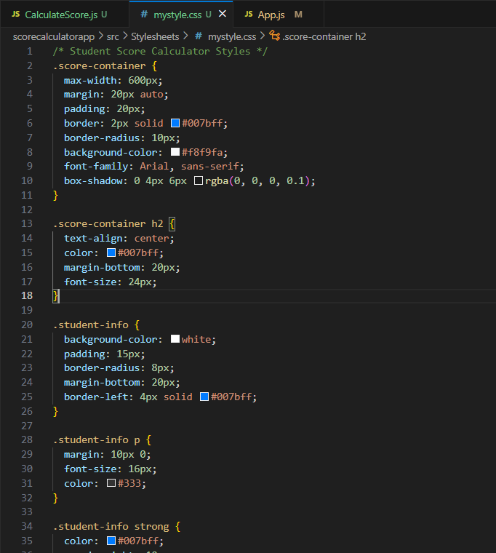

**4 .** Edit the App.js to invoke the CalculateScore functional component .

**App.js :**

import React from 'react';

import CalculateScore from './Components/CalculateScore';

function App() {

  return (

    <div className="App">

      <CalculateScore

        name="Steeve"

        school="DNV Public School"

        total={284}

        goal={300}

      />

    </div>

  );

}

export default App;

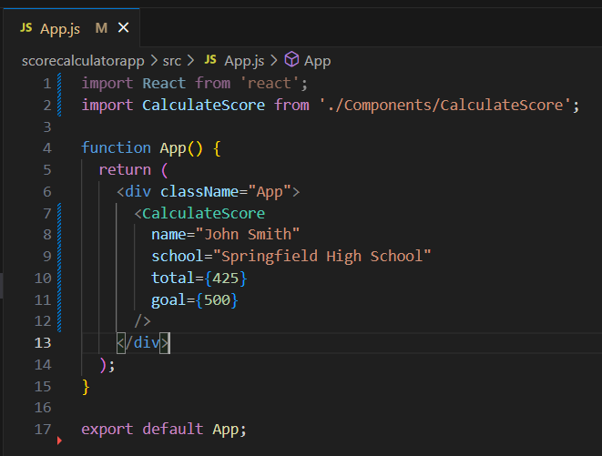

**5. run app using command npm start**

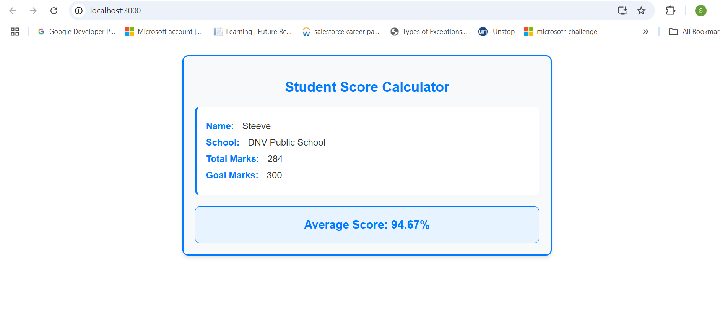

**I modified the css slightly for better UI .**

**Hence done with task 3 of Week6 Handson**